 | SIMATS ENGINEERING  Department of Computer Science and Engineering  CSA15 Cloud Computing and Big Data Analytics  CO2 AT3 - Capstone Cloud Infrastructure Case Analysis and Defense  Editable student template for application-based cloud virtualization and SDDC/cloud operations defense
Assessment Metadata
Course Code | CSA15
Course Title | Cloud Computing and Big Data Analytics
Assessment | CO2 AT3 - Capstone Cloud Infrastructure Case Analysis and Defense
Submission Type | Individual digital case analysis and infrastructure defense based on the same capstone title used in CO1, CO2 AT1 and CO2 AT2
Faculty | Dr C. Rajesh Babu
Employee ID | SSETSCS415
Submission Mode | Completed DOCX template and GitHub repository link through Google Classroom
How This Template Works
- Use the same capstone title used in CO1, CO2 AT1 and CO2 AT2.
- Do not recalculate all VM sizing or repeat all configuration screenshots. Summarize the final AT1/AT2 evidence and use it for design defense.
- Answer all five questions with application-oriented reasoning connected to the capstone product.
- Include sustainable cloud operation decisions wherever relevant: right-sized resources, log retention, storage lifecycle, scheduled shutdown, API-call reduction and VM/container/serverless comparison.
- Paste the final topology diagram in the given response area. The sample diagram is only a structure; redraw it for the student's own product.
- Upload this completed document and supporting evidence to GitHub, then submit the repository link through Google Classroom.
Assessment Focus
AT1 answered what VM is required. AT2 showed configuration or simulation evidence. AT3 asks whether the student can defend the complete infrastructure design under application, security, operations and failure conditions.
Student and Capstone Details
Student Name | K.Varshini
Register Number | 192472358
Class / Slot | Slot B
Capstone Title | SkillHire: AI Resume Screening and Job-Fit Android App
CO1 Evidence Link | https://github.com/varshinvarma1010/CSA1512
CO2 AT1 VM Recommendation | vCPU: _2___ RAM: __4__ GB Storage: __30__ GB VM Class: standard B2s(Asure)____
CO2 AT2 Evidence Link | https://github.com/varshinvarma1010/CSA1512
GitHub Repository Link | https://github.com/varshinvarma1010/CSA1512
Submission Date | 3-08-2026
Evidence Carry-Forward Summary
Evidence Source | Student Entry | How It Supports AT3 Defense
Evidence Source | Student Entry | How It Supports AT3 Defense
CO1 Concept Map | Concept map completed | Shows cloud concepts used in project
CO2 AT1 Sizing Workbook | Azure VM sizing | Justifies VM configuration
VM Calibration Sheet | CPU, RAM and Storage | Confirms selected VM meets workload
CO2 AT2 Practical Evidence | Ubuntu VM screenshots | Shows successful deployment
Q1: Virtualization Value and Capstone Cloud Deployment Summary
Explain your capstone product, expected workload, cloud need and deployment context. Analyze how virtualization improves cost efficiency, resource utilization, workload isolation, infrastructure flexibility and cloud deployment readiness for your product.
Design Point | Student Response
Capstone Product | Your project name
Expected Workload | Medium workload with multiple users
Cloud Need | Scalable, reliable cloud infrastructure
Virtualization Value | Multiple VMs can run on one physical server
Cost & Utilization | Better hardware utilization and reduced cost
Isolation & Flexibility | Independent VM environment with easy scaling
Case Analysis Response: Write 8-12 technical lines connecting virtualization value to your capstone product.
SkillHire is an AI-powered Android application that helps job seekers upload resumes and receive job recommendations based on AI-powered resume screening. The application is expected to serve around 100–500 users, requiring reliable computing resources, secure storage, and efficient processing. Virtualization enables multiple services to run on the same physical hardware while maintaining isolation between workloads. The selected Ubuntu Server virtual machine provides a stable platform for deploying the backend API, AI module, and database services. Virtualization also allows resources such as CPU, RAM, and storage to be allocated efficiently according to application demand, reducing infrastructure costs. If user traffic increases, additional virtual machines or containers can be deployed without affecting existing services. The use of virtualization improves system availability, simplifies maintenance, supports disaster recovery through snapshots, and prepares the application for future cloud scalability. Overall, virtualization provides flexibility, security, cost efficiency, and better resource utilization for the SkillHire application.
Q2: Rapid Provisioning, Testing and Virtual Machine Lifecycle Case
Using your CO2 AT1 VM recommendation and CO2 AT2 practical evidence, explain how virtual machines, VM images, templates, snapshots, clones or containers support rapid provisioning, testing, deployment, rollback and maintenance for your capstone product.
Lifecycle Element | AT1/AT2 Evidence Used | Capstone Use / Justification
VM image or base environment | Ubuntu 24.04 Image | Quick VM deployment
Template or repeatable setup | Azure VM configuration | Reuse configuration
Snapshot / rollback | VM snapshot | Rollback after failure
Clone / testing copy | Duplicate VM | Testing environment
Container or VM decision | Virtual Machine | Better OS-level control
Maintenance and update plan | Azure Updates | Regular Patching
Case Analysis Response: Explain how lifecycle practices reduce deployment delay and risk.
Virtual machine lifecycle management plays an important role in reducing deployment time and operational risks. Ubuntu Server images provide a standardized environment that can be reused whenever new virtual machines are required. VM templates reduce manual configuration effort by providing identical server configurations. Snapshots create recovery points before software updates, allowing quick rollback if failures occur. Full VM clones provide isolated testing environments where new features can be evaluated without affecting production services. Docker containers package the backend API and AI resume screening module with all required dependencies, ensuring consistent execution across development and production environments. Regular software updates, automated backups, monitoring, and scheduled maintenance further improve system reliability. These lifecycle management practices reduce downtime, improve recovery capability, and simplify infrastructure management throughout the application lifecycle.

Q3: Final Cloud Deployment Topology and SOA/API Service Integration Case
Draw and explain the final deployment topology for your capstone product. Show frontend, backend/API, database, storage, authentication, notification, analytics and any VM/container/managed cloud service components. Explain how SOA/API-based integration connects these modules and supports modular cloud service design.→

Python Flask Backend API (Docker Container on VM) VM) ononVM)
End Users
(Job Seekers/Recruiters))
Android Mobile App (Frontend)

Firebase cloud messeging (notifications)
(User Login & Security)

Firebase Cloud Messaging(Notifications)
Firebase Authentication
(User Login & Security)

AI Resume Screening Module
(Python + AI)

Azure Monitor
Analytics / Monitoring

Ubuntu Server 24.04 LTS Docker Engine Hosting Backend & AI Services

Component | Technology | Type | Integration
Frontend | Web Browser | Client | HTTPS
Backend/API | Python Flask | VM | REST API
Database | MySQL | VM | SQL
Storage | Azure Storage | Managed | Storage API
Authentication | Login Module | Managed | OAuth/Login
Notification | Email Service | SaaS | SMTP/API
Analytics | Azure Monitor | Managed | Monitoring API
Paste or draw the final capstone deployment topology diagram here.
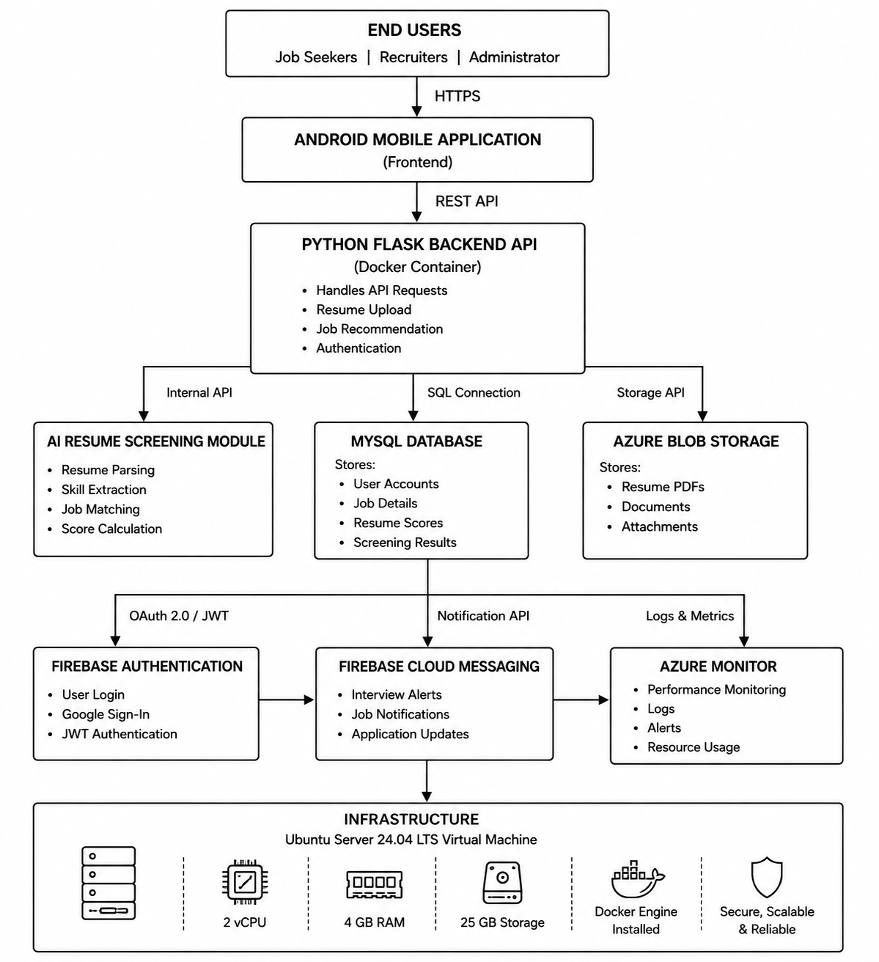
SOA/API Integration Explanation: Explain how services communicate and why modular service design is useful.
The SkillHire application follows a Service-Oriented Architecture (SOA), where each component performs a dedicated function while communicating through REST APIs. The Android frontend sends requests to the Python Flask backend for user authentication, resume uploads, and job recommendation services. The backend communicates with the MySQL database to store user information, job postings, and screening results. Uploaded resumes are securely stored in Azure Blob Storage, while the AI screening module processes resume content and returns matching scores through internal APIs. Firebase Authentication manages secure user login, and Firebase Cloud Messaging sends notifications regarding application status and job recommendations. Because each service operates independently, updates can be applied without affecting other components. This modular architecture improves scalability, maintainability, reliability, and overall cloud deployment efficiency.
Q4: Design Alternatives, Identity, Access and Federated Cloud Privacy Case
Compare at least two deployment alternatives for your capstone product, such as single VM, multi-tier VM, containerized deployment, managed backend, federated cloud or hybrid cloud model. Justify the selected design by analyzing identity management, role-based access control, federated access, data sharing, privacy protection and security risks.
Deployment Alternative | Advantages | Limitations / Risks |  | Identity and Privacy Impact
Alternative 1 | simple | Limited scalability |  | Basic login
Alternative 2 | Better Performance | Higher cost |  | Strong RBAC
Selected design | Multi-tier VM | Best balance |  | Better security
Security Area |  |  | Student Decision
User Roles |  |  | Job Seeker, Recruiter and Administrator
Authentication Method |  |  | Firebase Authentication
Role-Based Access Control |  |  | Different permissions for each user role
Federated Access / Partner Access |  |  | Google Sign-In supported
Sensitive Data Handled |  |  | User profiles, resumes and AI screening results
Privacy Protection Decision |  |  | HTTPS encryption, password hashing, encrypted storage and RBAC
Case Analysis Response: Defend why the selected design is better for identity, access and privacy.
Among the evaluated deployment options, the multi-tier cloud architecture using Docker containers and managed cloud services was selected because it provides the best combination of scalability, security, and maintainability. Firebase Authentication securely verifies user identities while Role-Based Access Control (RBAC) ensures that job seekers, recruiters, and administrators can only access authorized resources. Federated authentication through Google Sign-In improves user convenience and reduces password management risks. Sensitive information such as resumes, user profiles, and screening results is protected through encrypted communication using HTTPS and secure cloud storage. Docker containers isolate application components, preventing failures from spreading across the system. Compared with a single virtual machine deployment, the selected architecture offers higher availability, easier scaling, and stronger identity management. Therefore, it is more suitable for future production deployment.
Q5: Software-Defined Datacenter and Cloud Operations Defense Case
Analyze how your infrastructure will respond to operational and failure scenarios such as VM failure, database growth, traffic spike, credential leakage, service outage, resource contention or cost increase. Explain how SDDC concepts and cloud operations practices such as automated provisioning, software-defined networking, software-defined storage, monitoring, logging, backup, rollback, scaling, resource control and maintenance improve the final infrastructure design. Include Green Computing decisions such as resource right-sizing, storage lifecycle control, log retention, API-call reduction, scheduled shutdown, VM/container/serverless comparison and carbon/energy proxy indicators where relevant.
Operational / Failure Scenario | Expected Impact | SDDC / Cloud Operations Response | Evidence or Control
VM Failure | Service interruption | VM snapshot recovery | VM Backup
Database Growth | Reduced performance | Database storage scaling | Managed Database
Traffic Spike | Slow response | Auto Scaling | Azure Monitor
Credential Leakage | Unauthorized access | Password reset, MFA and RBAC | Firebase Authentication
Service Outage | Temporary downtime | Backup VM and monitoring | Health Checks
Resource Contention | High CPU and memory usage | Dynamic resource allocation | Azure Monitoring
Cost Increase | Higher operational cost | VM right-sizing and scheduled shutdown | Azure Cost Management
Operational Readiness Area |  | Student Plan
Automated provisioning |  | VM templates and Docker deployment
Software-defined networking |  | Azure Virtual Network
Software-defined storage |  | Azure Blob Storage
Monitoring and logging |  | Azure Monitor and Log Analytics
Backup and rollback |  | VM Snapshots and Database Backup
Scaling and elasticity |  | Horizontal and Vertical Scaling
Resource control and maintenance |  | Continuous monitoring and scheduled maintenance
Green Computing and sustainability control |  | Right-sized VM, scheduled shutdown and storage cleanup
Green Cloud Decision |  | Student Justification
VM right-sizing from CO2 AT1 |  | 2 vCPU and 4 GB RAM provide sufficient resources without unnecessary cost.
VM vs container vs serverless choice |  | Docker containers improve deployment efficiency while VM hosts infrastructure securely.
Scheduled shutdown / idle-resource control |  | Idle VMs are automatically stopped to reduce energy usage and cloud cost.
Log and file retention policy |  | Logs retained for 30 days and unnecessary files deleted periodically.
Storage lifecycle and backup cleanup |  | Old backups and unused resumes are archived or removed regularly.
API-call or polling reduction |  | Caching and optimized API requests reduce unnecessary network traffic.
Carbon/energy proxy indicator to track |  | CPU utilization, storage usage, VM uptime and power-efficient resource utilization.
Final Infrastructure Defense Statement: State whether the design is ready for prototype, pilot or production. Defend reliability, security, SDDC/cloud operations and Green Computing improvements required next.
The proposed cloud infrastructure for SkillHire is suitable for prototype deployment and can be extended for pilot or production environments with minimal modifications. The selected Ubuntu Server virtual machine provides sufficient computing resources for the backend API, AI resume screening engine, and database operations. Docker containers simplify application deployment while ensuring consistency across environments. Managed cloud services such as Azure Blob Storage and Firebase Authentication improve availability, security, and maintenance efficiency. Monitoring, logging, backup, snapshots, and automated recovery increase infrastructure reliability during failure scenarios. Auto-scaling and resource monitoring allow the application to handle increasing workloads efficiently. Green Computing practices, including VM right-sizing, scheduled shutdown of idle resources, log retention policies, storage lifecycle management, and optimized API usage, reduce cloud costs and energy consumption. Overall, the infrastructure is reliable, scalable, secure, and well-prepared for future production deployment.
CO2 Reflection and Individual Defense
This section must be individually written. It should show what the student understands from the complete CO2 chain: infrastructure sizing, practical configuration evidence and final operations defense.
Reflection Prompt | Student Response
What is the strongest infrastructure decision in your capstone design? | Using Docker containers with Ubuntu VM for modular, scalable and secure deployment.
Which CO2 concept became clearer after AT1, AT2 and AT3? | Virtualization, VM lifecycle, cloud deployment and SDDC concepts became much clearer.
Which risk is most serious for your capstone: failure, cost, privacy, scaling or sustainability? | Privacy is the biggest concern because confidential resumes and personal information are processed.
What evidence would you show during viva to defend your infrastructure design? | VM configuration, Docker deployment, snapshots, monitoring screenshots, architecture diagram and GitHub repository.
What will you improve before final capstone deployment? | Implement Kubernetes orchestration, AI optimization, auto-scaling and stronger cloud security policies.

Student-Facing Assessment Criteria
Criteria | Descriptor
Capstone continuity | The answer uses the same capstone title and connects CO1, CO2 AT1 and CO2 AT2 evidence.
Virtualization and lifecycle reasoning | VM, image, snapshot, clone, container or managed-service decisions are technically justified.
Topology and integration clarity | Architecture diagram and SOA/API explanation show clear module interaction.
Identity, access and privacy | Roles, authentication, RBAC, federated access, sensitive data and privacy decisions are defended.
SDDC/cloud operations | Failure response, monitoring, logging, scaling, backup, rollback and resource control are addressed.
Green Computing defense | Right-sizing, retention, API efficiency, idle-resource control and sustainable cloud choices are explained.
Submission quality | GitHub, template completion, evidence references and individual reflection are complete.
GitHub and Google Classroom Submission
Repository Item | Expected Content
README.md | Capstone title, student details, final VM recommendation, deployment topology summary and AT3 evidence index.
Completed AT3 document | This completed editable DOCX or exported PDF if instructed.
Diagram image | Final topology diagram if created separately.
Evidence references | Links or screenshots from CO1, CO2 AT1 and CO2 AT2 as needed.
Green Computing note | Short README section explaining sustainable cloud choices and resource-control decisions.
Google Classroom | Submit the GitHub repository link through GCR.
Student Assurance
I confirm that this case analysis, design reasoning, topology diagram and final defense statement were prepared individually by me for the stated capstone title. I have not uploaded passwords, tokens, private keys or sensitive account information.
Student Name | K.Varshini
Register Number | 192472358
Signature | K.varshini
Date | 03-08-2026

Faculty Verification
Faculty Name | Dr C. Rajesh Babu
Employee ID | SSETSCS415
Constructive Feedback / Remarks
Strength Observed
Improvement Suggested
Signature / Date

